**Insights of the Dataspark project**

* Here are some insights based on the visualization:

1. **Uniform Distribution**:
   * The histogram bars appear to be roughly uniform in height, suggesting that the CustomerKey values are evenly distributed across the dataset. This might indicate that the CustomerKey is either a sequential or randomly assigned unique identifier.
2. **No Significant Outliers**:
   * There don't appear to be any significant outliers in the distribution. Most values are within a similar range, with counts ranging between approximately 500 to 700 across different bins.
3. **Bin Count**:
   * The number of bins is relatively large, which implies that the CustomerKey values are likely distinct and numerous. This could be typical for a primary key or unique identifier in a customer dataset.
4. **Interpretation**:
   * If CustomerKey is a unique identifier (such as a primary key), this distribution is expected, and the uniform distribution reflects the uniqueness of the key values.
   * If you expected CustomerKey to have a more meaningful distribution (e.g., customer segments or types), the uniformity may suggest that it is not a meaningful categorical variable but rather a mere identifier.

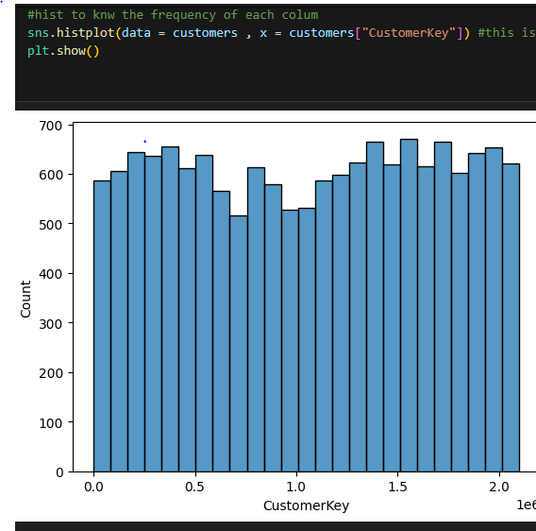

* The bar chart you've provided shows the distribution of customers by gender, as visualized using a countplot. Here are some key insights:

**1. Gender Distribution:**

* **Slight Male Majority**: The chart indicates that the number of male customers is slightly higher than the number of female customers. Both categories have similar counts, with males being just marginally more prevalent.

**2. Close to Balanced Gender Ratio:**

* The counts for male and female customers are quite close to each other, suggesting that the customer base is almost evenly split between the two genders. This is valuable in understanding the diversity of your customer base.

**3. Implications for Marketing Strategies:**

* Since the gender distribution is nearly balanced, marketing strategies should consider targeting both genders equally. Any gender-specific campaigns could be fine-tuned to address the slight difference, but overall, there’s no strong skew toward one gender.

**4. Potential for Further Analysis:**

* **Cross-Analysis**: It might be useful to cross-analyze this gender data with other customer attributes, such as age, purchase behavior, or product preferences, to uncover more detailed insights.
* **Segment Analysis**: If the goal is to create specific gender-focused marketing or services, more granular analysis could be done by splitting this further, perhaps by looking at product categories or customer lifetime value by gender.

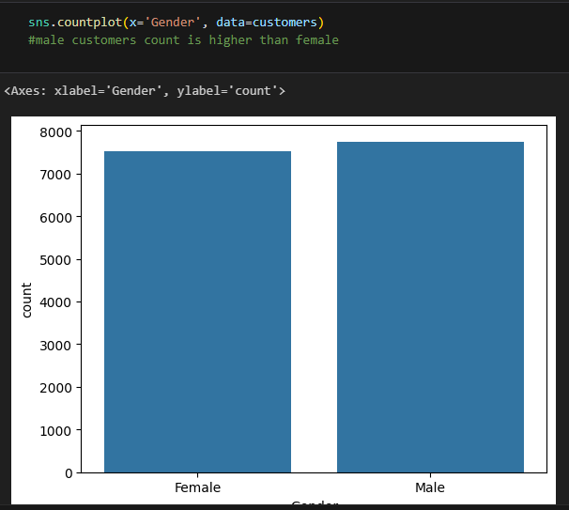

* The bar chart you provided shows the distribution of customers by country. Here are the key insights:

**1. Dominance of the United States:**

* The United States has the highest count of customers by a significant margin, with over 7,000 customers. This suggests that your business has a strong presence in the U.S. market compared to other countries.

**2. Distribution Across Other Countries:**

* The United Kingdom is the next largest market, followed by Australia, Canada, and Germany, each with a similar but smaller customer base.
* France, Italy, and the Netherlands have the smallest customer counts among the countries listed.

**3. Potential Market Focus:**

* **Primary Market**: Given the large customer base in the United States, it might be beneficial to focus marketing efforts, product launches, and customer service enhancements in this region to further capitalize on your strong presence.
* **Secondary Markets**: The United Kingdom and Australia could be secondary focus areas, as they also have a significant number of customers.
* **Emerging Markets**: Countries like France, Italy, and the Netherlands could be seen as emerging markets with potential for growth. Strategic marketing campaigns or localized services could help increase customer counts in these regions.

**4. Resource Allocation:**

* The data suggests that you may want to allocate more resources, such as marketing budget, customer support, and product customization, to the U.S. market given its dominance.
* However, don't neglect the other countries, as they collectively contribute a substantial part of your customer base.

**5. Further Analysis:**

* **Customer Behavior**: It may be helpful to analyze customer behavior in each country to understand why the U.S. market is so dominant. Are there particular products or services that are more popular in the U.S.?
* **Market Potential**: Evaluate the potential for growth in the smaller markets. Are there any barriers to entry, such as localization or cultural preferences, that could be addressed to boost customer numbers?

